**Name: Session:**

**Programming I**

**Lab Exercise 9.30.2021**

When you have completed these programs, submit your documented source code.

1. Write a program that calculates and prints the sum of all even integers from 2 to 10000 (inclusive)
2. Write a program that calculates the sum of all perfect squares between 1 and 10000 (inclusive). Hint: Consider writing a function *isPerfectSquare*.
3. Write a program that prints all powers of 2 from 20 to 240.
4. Write a program that prints the sum of all odd numbers between a and b (inclusive) where a and b are integers provided by the user.
5. Write a program that calculates the sum of all odd digits in an integer provided by the user. For example if 32677 in input, the sum should be 3 + 7 + 7 = 17.
6. The *Fibonacci numbers* are defined by the sequence

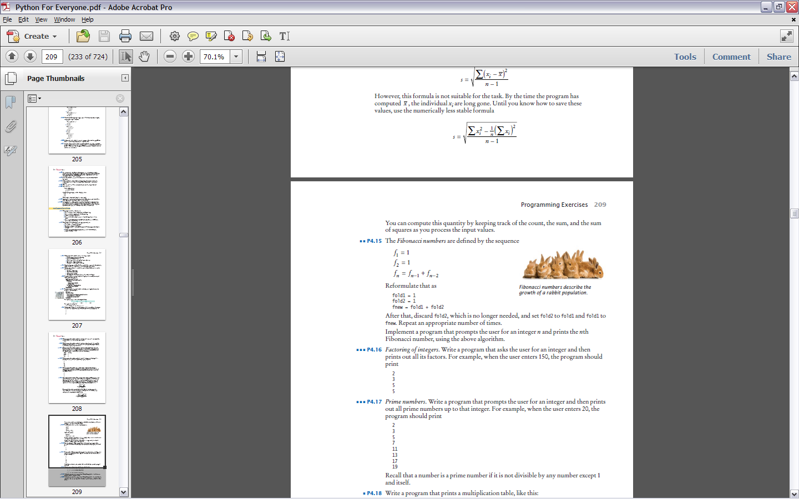

Reformulate that as

fold1 = 1

fold2 = 1

fnew = fold1 + fold2

After that, discard fold2, which is no longer needed, and set fold2 to fold1 and fold1 to

fnew. Repeat an appropriate number of times.

Implement a program that prompts the user for an integer *n* and prints the *n*th Fibonacci number, using the above algorithm.